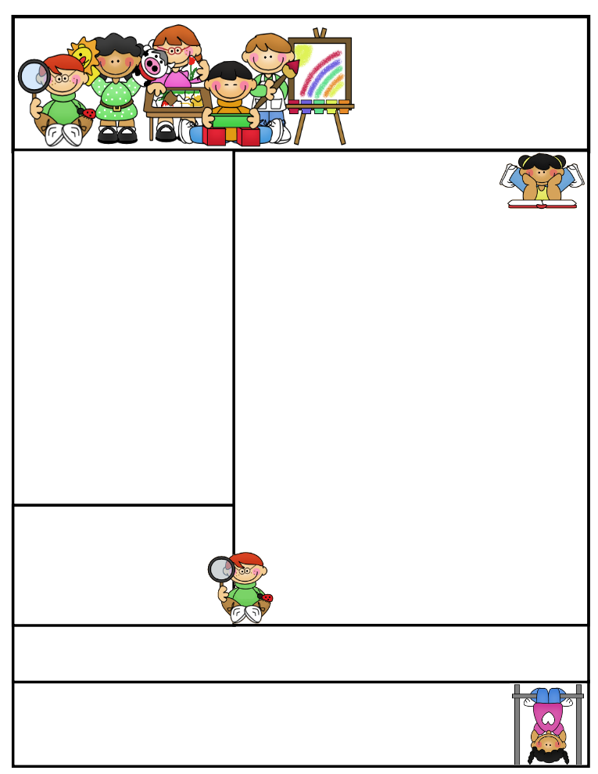

Classroom News:

Welcome back from summer and welcome to 2nd grade! It is going to be a fantastic year together!

It was nice meeting a lot of you at our 2nd grade open house. I hope your child is as excited as I am to start the new school year! Don’t forget to join us Tuesday, Sept. 16th at 5:30, for our Back to School Night, where I will go over the basics of our classroom.

Considering the warm temperatures, make sure your child has a water bottle labeled with his/her name on it.

Since it is the beginning of the year, there have been lots of papers sent home that need to be signed and returned. Please make sure to send them back with your child as soon as possible.

Email address: lisae@psdschools.org  
class website: http://evans2ndgrade.weebly.com

Tavelli site: www.tavellielementary.org

Mrs. Evans   
Tavelli Elementary School

Classroom: (970) 488-6750

Reminders: Please check our school and class website for updates.

Birthdays:

no birthdays this month

Important Dates:

Mrs. Evans’

Classroom Newsletter

August 2014

**August 18th**- Open house at Tavelli 9:00-10:00 am

**August 19th**- 1st day of school

**August 19-29th**- Heat Day early release at 1:38pm

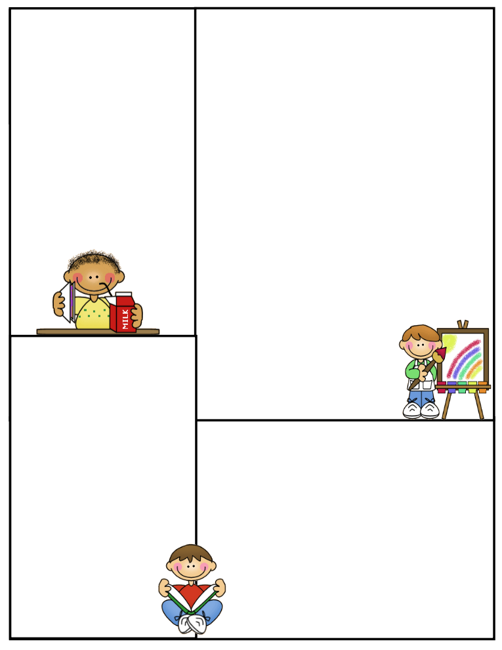

**Math**

Unit: 1 Numbers and Place Value

Basic review of math facts, numbers, and place value.

**Please make sure you have paid your child’s classroom teacher $10.00 for the math journal.**

**Science/Social Studies**

Science: Mrs. Musante, our science lab teacher, will be working in our science lab with the students. She will begin the year with the scientific process.

**Literacy**

Treasures Theme: Friends and Family

Unit Question: What makes a good friend?

Skills: Fluency, phonemic awareness, and vocabulary development

Comprehension: story elements-characters, setting, plot, main ideas and details, and making predictions

Spelling Patterns: Short and

long vowels

**Writing**

We will begin the year with a review of how to write a sentence. We will focus on sentence structures.