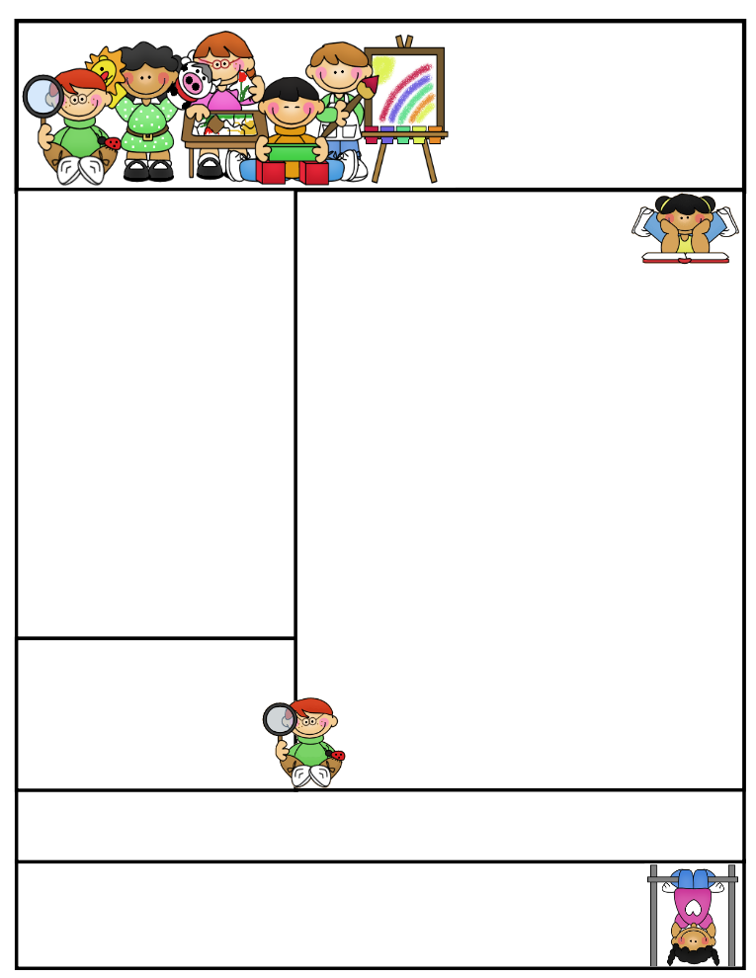

Classroom News:

October has arrived already and I can’t believe how quickly September flew by! We’ve been hard at work in the classroom and are enjoying the cooler weather.

The walkathon is coming! The walkathon is our fall school wide fundraiser. Students are encouraged to get donations for the school. We will be completing our laps (running or walking) on Oct. 10th during our regular specials time of 12:50-1:35. You are welcome to come out and cheer us on!

Parent teacher conferences are right around the corner. Please be watching for your assigned conference date and time sheet to come home. Please let me know as soon as possible if you can/can’t make it. I am looking forward to meeting with you all and sharing information about your child.

Remember to send a healthy snack to school with your child. If anyone would like to donate snacks for children who forget, please send them to school with your child and I will keep them in the classroom.

October 10th-Walkathon

October 16th and 17th-No school-parent teacher conferences

October 24th-Cornstalk Carnival

|  |
| --- |
|  |
|  |
|  |

October Birthdays:

Kallee – Oct. 18th

Jackson – Oct. 24th

Email address: lisae@psdschools.org  
class website: http://evans2ndgrade.weebly.com

Tavelli site: www.tavellielementary.org

Mrs. Evans   
Tavelli Elementary School

Classroom: (970) 488-6750

Reminders: Please check our school and class website for updates.

Important Dates:

Mrs. Evans’

Classroom Newsletter

October 2014

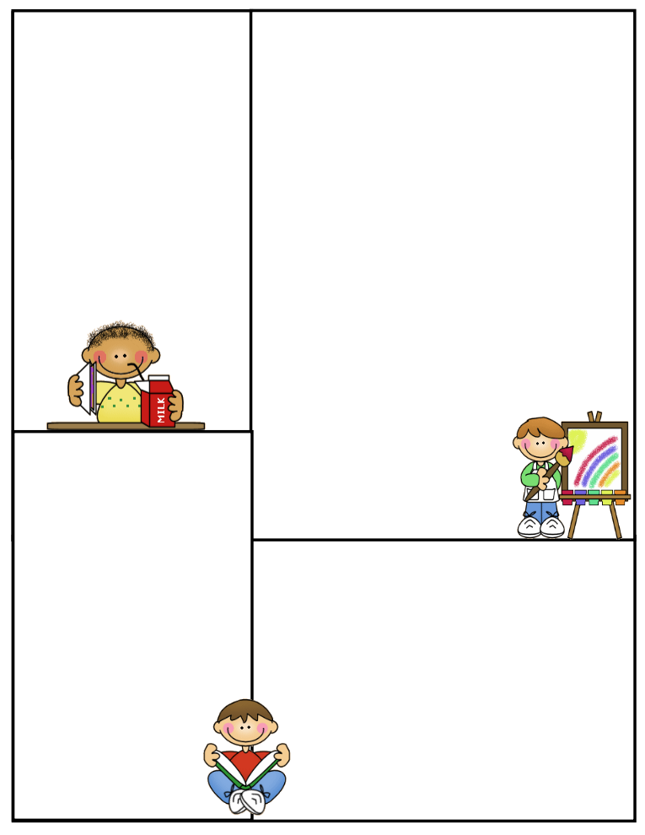

**Science/Social Studies**

Science: We are getting ready to begin our cardboard challenge. Please send in any cardboard scraps/boxes to help with this project.

In class we are learning more about civics and beginning to learn more about Fort Collins History.

**Literacy**

Treasures Theme: Community Heroes

Unit Question: What heroes live in your community?

Skills: Fluency, phonemic awareness, and vocabulary development

Comprehension: story elements (characters, setting, plot), main ideas and details, cause and effect, compare and contrast, and inferences.

Spelling Patterns: long vowels

**Math**

We are just wrapping up unit one and moving on to unit 2. We are working on place value, addition and subtraction facts, and time.

**Writing**

We are working on opinion and descriptive writing. We are writing in small groups to meet all writing needs.