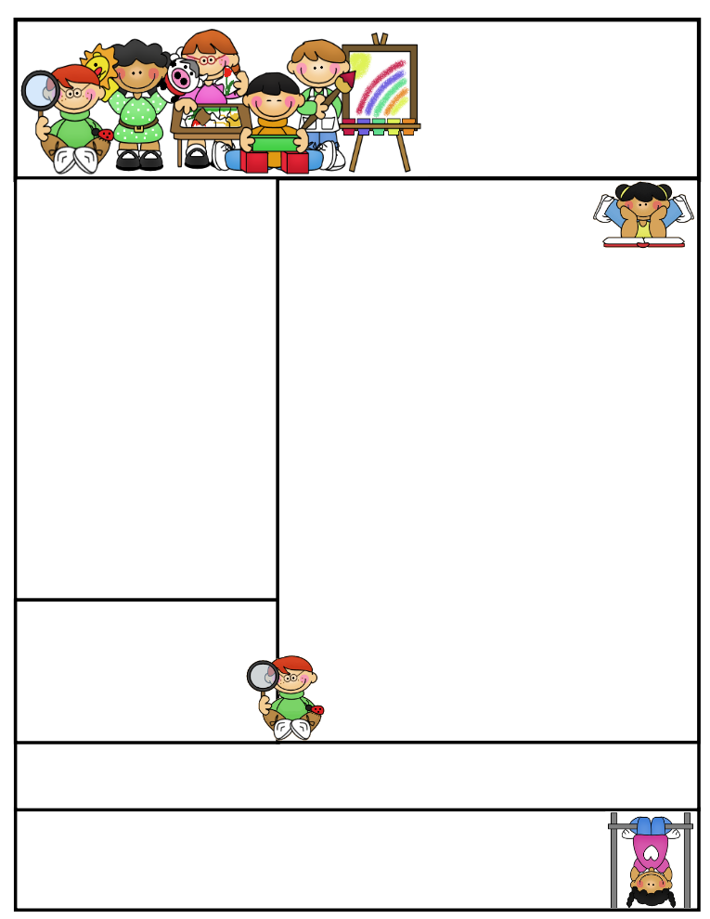

Classroom News:

Wow, August has flown by! It was nice getting back into the swing of things with our early release days, and we’ve transitioned well into full days this week.

We have been gathering fall data from the kids. They have been working so hard showing us what they know. We will be discussing this data with you at our fall conferences.

Scholastic book orders will go home next week and will be due the week after.

Classroom Birthdays: We have two birthdays this month! To celebrate birthdays, students can choose to bring a treat or have 10 minutes of extra recess or free time. We do have some peanut allergies to consider if you decide to send a treat.

Email address: lisae@psdschools.org  
class website: http://evans2ndgrade.weebly.com

Tavelli site: www.tavellielementary.org

Tavelli site: www.tavellielementary.org

Mrs. Evans   
Tavelli Elementary School

Classroom: (970) 488-6750

**Sept. 2nd** – Vision and Hearing testing

**Sept. 8th** – Picture Day

**Sept. 16th** -2nd Grade: Back to School Night 5:30-6:00 pm

**Sept. 18th** –Book orders DUE

**Sept. 18th** – Tavelli Tiger World 20th Anniversary Celebration 5:00-7:00 pm

Reminders: Please check our school and class website for updates.

Birthdays:  
Issac Sept. 11  
Chloe Sept. 15

Important Dates:

Mrs. Evans’

Classroom Newsletter

September 2014

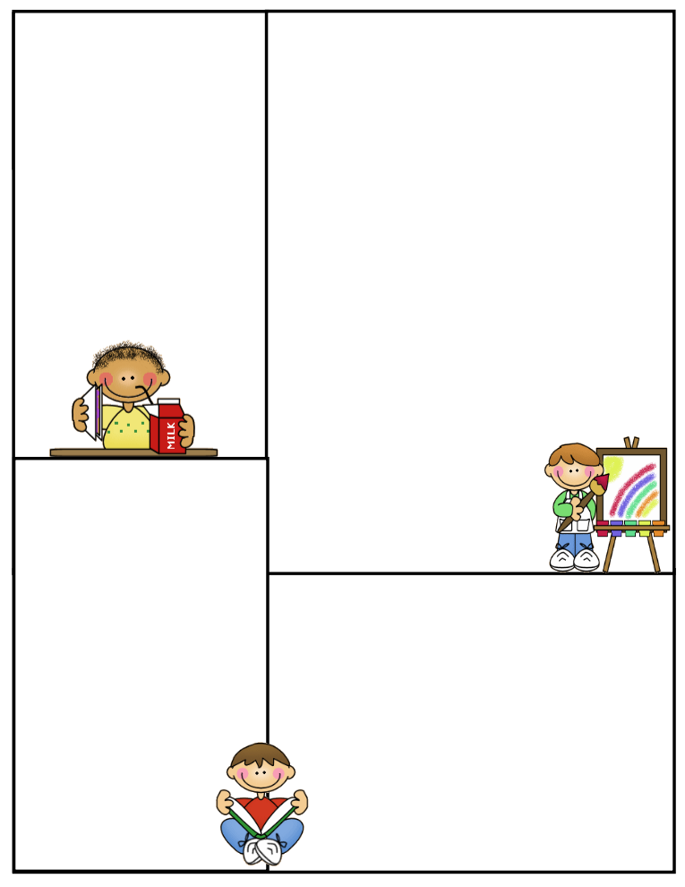

**Math**

Unit: 1 Numbers and Place Value

Basic review of math facts, numbers, and place value.

Please make sure you have paid your child’s classroom teacher $10.00 for the math journal.

**Science/Social Studies**

Science: Mrs. Musante will be working in our science lab with the students. She will begin the year with the scientific process.

In our classrooms, we will be working on our civics and communities units.

**Literacy**

Treasures Theme: Friends and Family

Unit Question: What makes a good friend?

Skills: Fluency, phonemic awareness, and vocabulary development

Comprehension: story elements-characters, setting, plot, main ideas and details, and making predictions

Spelling Patterns: Short and

long vowels

**Writing**

We will begin the year with a review of how to write a sentence. We will focus on sentence structures.